October 20, 2017  Pacific Forest and Watershed Lands Stewardship Council  3300 Douglas Boulevard, Suite 250  Roseville, CA 95661  (916)-297-6660  info@stewardshipcouncil.org | 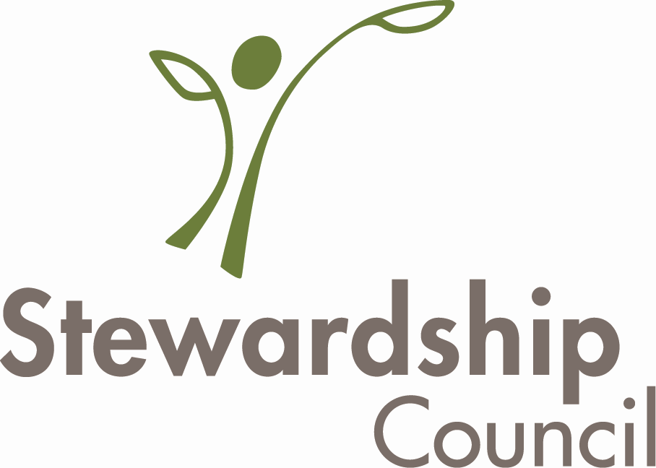
For Immediate Release: Protection of Iconic 4,491-acre McArthur Swamp Property in Shasta County
This month, Pacific Gas and Electric Company (PG&E) donated 4,491 acres at the McArthur Swamp to the Fall River Resource Conservation District (RCD), followed immediately by the RCD’s donation of a permanent conservation easement to Ducks Unlimited (DU). This newly protected acreage at McArthur Swamp is located just north of the town of McArthur in eastern Shasta County.
The property is located within the ancestral territory of the Ahjumawi Band of the Pit River Tribe. In addition, it contains important agricultural lands and provides significant habitat and public recreational values. Through the conservation easement, DU and the RCD are ensuring the permanent protection of open space, plant and wildlife habitat, agricultural uses, outdoor recreation by the general public, and historic and cultural values.
The protected land provides essential food, breeding grounds, wintering habitat, and nesting cover for birdlife. The property also provides opportunities for public recreation including hunting, wildlife viewing and bird watching. In addition, the property’s grasslands provide forage for cattle grazing that has been used by local grazers for more than 70 years.
The Fall River RCD will manage the McArthur Swamp property collaboratively with a management team comprised of the RCD, the Pit River Tribe, and a Technical Advisory Committee.
The Fall River RCD was established in 1957 by the Shasta County Board of Supervisors. It is a public entity responsible for resource conservation in a geographical area encompassing 1,149,000 acres across four counties, with the majority of that acreage in Shasta County. "We look forward to working with our partners and the community to continue the good stewardship of the McArthur Swamp exemplified by PG&E and the McArthur Resource Management Association,” said Mike Millington, a Board Member of the Fall River RCD.
DU became a nonprofit in 1937 and operates in the United States, Canada, and Mexico and has conserved over 5.5 million acres in the United States. DU has an experienced staff and board of directors with expertise in wetland restoration, waterfowl habitat, agriculture, wildlife biology, recreation, and FERC relicensing. DU has established policies and standards regarding monitoring and enforcement of conservation easements and is an accredited land trust with the national Land Trust Alliance (LTA). John Ranlett, DU’s regional biologist who has been involved in the project for over 5 years stated, “The Fall River Valley region provides a major wetland linkage for migratory birds between the Klamath Basin and Oregon Closed Basin to the north and wintering grounds in the Central Valley to the south. We are very excited that this important habitat conservation project is finally coming to fruition”. Wetland and upland habitats protected by this easement will benefit numerous waterfowl, shorebirds, other waterbirds, and migratory landbirds that use the area in fall and spring migration, and at other key times during their annual life cycles including northern pintail, mallard, American wigeon, green-winged teal; white-fronted, snow and Ross’s, and Canada geese; sandhill cranes, and long-billed curlews; and variety of birds of prey including red-tailed, rough-legged, and ferruginous hawks.
PG&E agreed in a 2003 bankruptcy settlement to permanently protect the beneficial public values on their approximately 140,000 acres of watershed land associated with its hydroelectric generation facilities. In 2004, as part of the settlement, the Pacific Forest and Watershed Lands Stewardship Council was established to work with public entities and nonprofit conservation organizations to ensure these acres of California's pristine PG&E watershed lands in the Sierra Nevada, Cascades and North Coast Range are conserved for the public good. “The Stewardship Council is pleased to support the Fall River RCD and DU in the protection of the many beneficial public values of the McArthur Swamp property,” said Art Baggett, Stewardship Council Board President.
The conservation easement and fee title donation at McArthur Swamp include an express reservation of a right for PG&E’s continued operation and maintenance of hydroelectric facilities and associated water delivery facilities, including project replacements and improvements required to meet existing and future water delivery requirements for power generation and consumptive water use by existing users and will comply with any FERC license renewal or other regulatory requirements.
“PG&E is pleased to know that our good land stewardship of the McArthur Swamp will continue after our donating the land. We are happy to have partnered with Ducks Unlimited which holds the conservation easement and the Fall River Resource Conservation District which takes ownership. The land will continue to be available for the enjoyment of future generations just as it has been in the past,” said Mike Schonherr, a PG&E director who oversees implementation of the company’s Land Conservation Commitment.
The Stewardship Council Board approved the proposed Land Conservation and Conveyance Plan for the McArthur Swamp conservation easement and land donation in 2016. In recognition of the importance of the agricultural use of cattle grazing to the local economy and the unique wildlife habitat at McArthur Swamp, the Stewardship Council will also be providing the Fall River RCD with enhancement funding for the property.
PG&E will retain ownership of an additional 3,168 acres at McArthur Swamp, which will also be protected through a conservation easement held by DU. This conservation easement donation is expected to close escrow in early 2018. _______________________________________________________________
Pacific Forest and Watershed Lands Stewardship Council
3300 Douglas Boulevard, Suite 250
Roseville, CA 95661
(916)-297-6660
info@stewardshipcouncil.org

